EXPERIMENT – 12

(By: Aman Tyagi)

Aim: Configuration of docker and starting its container in vagrant.

1. Add the GPG key for the official Docker repository to your system.
2. Add the Docker repository to APT sources
3. Next, update the package database with the Docker packages from the newly added repo:

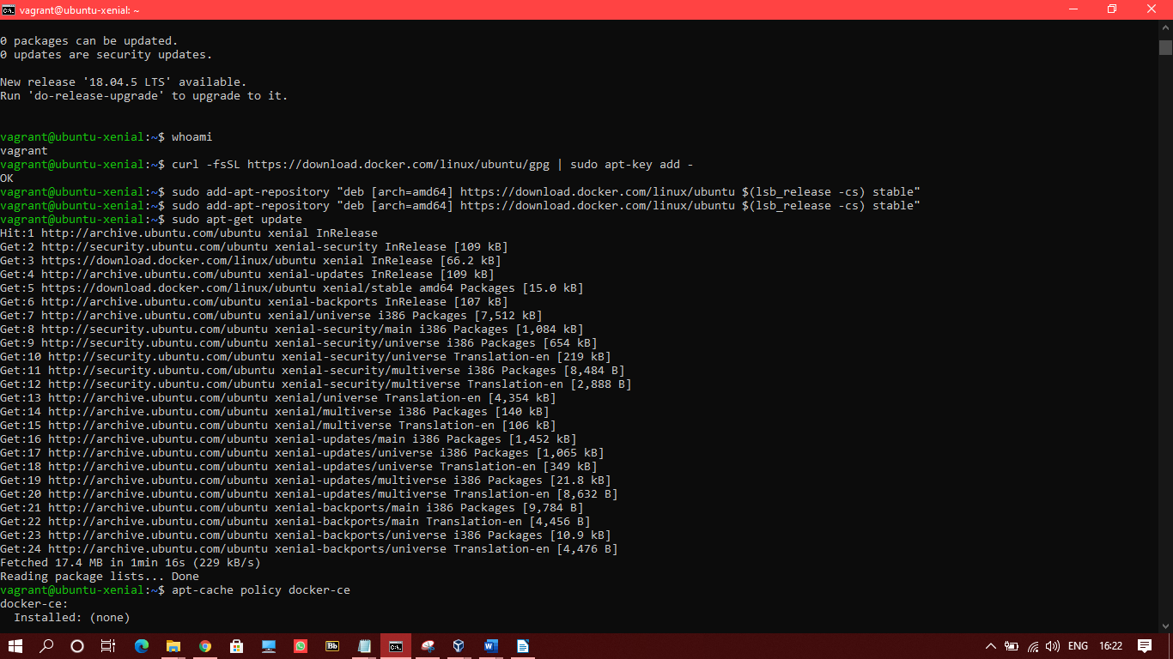

1. Install from the Docker repo instead of the default Ubuntu 16.04 repo

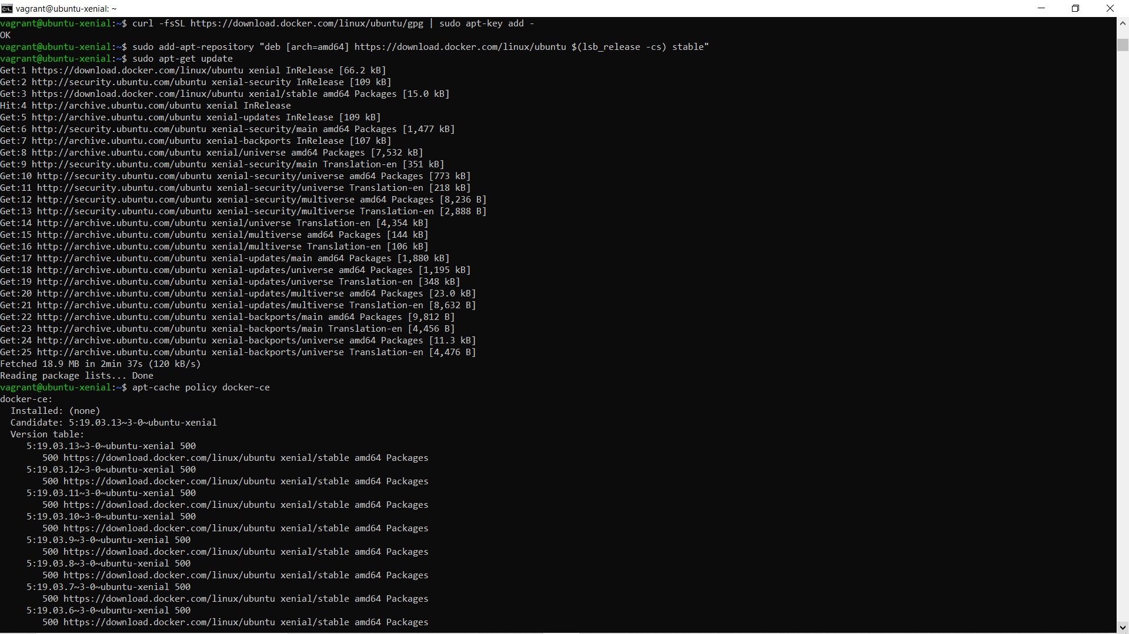

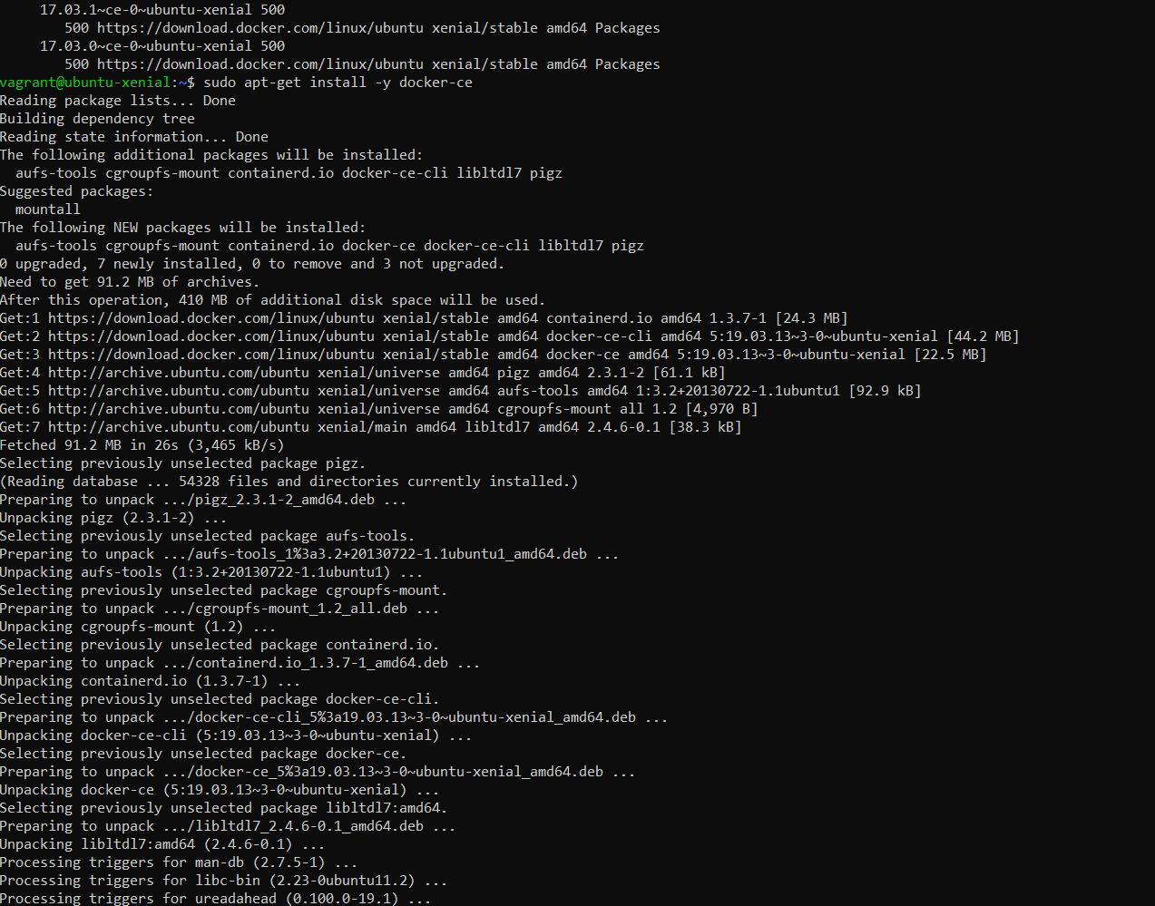

1. Checking and doing the configuration

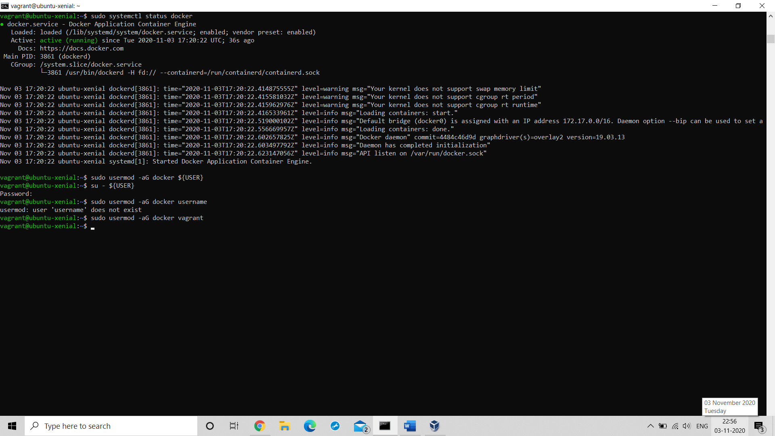

1. Pulling ubuntu

